Chicago Fashion Fix

Volume 2, Issue 4 November/ 2008



No Signs of Slowdown for Online Apparel Sales . . . Is Your Business Ready?

by Jennifer Burrell

Apparel is one of the fastest growing categories in e-commerce. With online apparel sales growth of 18% in 2007, it is obvious that consumers are getting more and more comfortable with shopping for clothing online. Online retailers, (or e-tailers, as they are sometimes referred to as), have begun to realize this, and are now contributing the time and resources towards making their online presence the best that it can be. Recognizing the importance of this sales channel, the Chicago Fashion Foundation hosted a two-part educational seminar entitled “Getting Connected and Growing your Fashion Business Online”, as a part of Fashion Focus Chicago 2008.

Approximately 100 students, business owners and industry professionals came to the Chicago Cultural Center on October 5th to get advice from a panel of Chicago based fashion related internet businesses. The panel included Jennifer Velarde, founder of 1154 Lill Studio (www.1154lill.com), Jamey Barrie, founder of Veruca Salt (www.verucasalt.com) and Greg Shugar, founder of The Tie Bar (www.thetiebar.com). Each business owner gave valuable information on internet marketing, search engine optimization and tips for having a successful online business.

Inside This Issue
No Signs of Slowdown for Online Apparel Sales… Is Your Business Ready?
Part II of Getting Connected and Growing Your Online Business: Keynote Speaker, Threadless.com
CFF's Annual Membership Networking Event
Success Story: Nicolette Karney and Lindsey Madigan of the SHE boutique
I FOUGHT IT ON eBAY
“Green” Fashion: A Legal Perspective
Fall Trends
A Word From the CFF Board

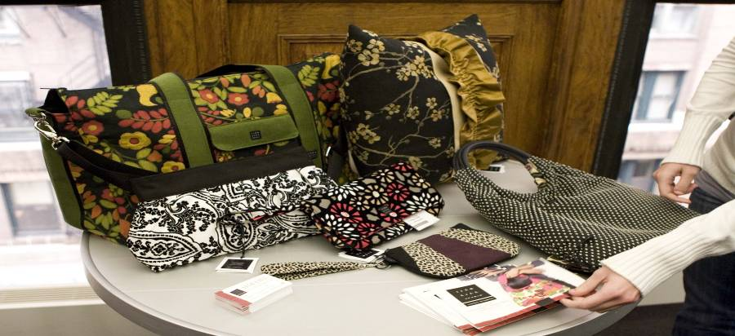

1154 Lill Studio is a custom handbag company with both an online presence and retail locations in Chicago, Boston, Kansas City and Philadelphia. The owner, Jennifer Velarde, stated that she started her business in 1995 because she “liked the process of creating raw materials into a usable good.” Velarde also shared some easy and inexpensive ways for small businesses to get their name out to the public. Some of these ways included registering multiple domain names so that people will always be able to reach your site (this is especially important for companies whose names that are often misspelled or have a sequence of numbers, like 1154 Lill Studio), online networking communities such as myspace and facebook, blogs, e-mail signatures and the inclusion of your website address on every piece of printed material that you distribute. Apparently, Velarde’s marketing and public relations savvy works - 1154 Lill Studio recently gained national exposure by being featured on Good Morning America.

1154 Lill Studio is a custom handbag company with both an online presence and retail locations in Chicago, Boston, Kansas City and Philadelphia. The owner, Jennifer Velarde, stated that she started her business in 1995 because she “liked the process of creating raw materials into a usable good.” Velarde also shared some easy and inexpensive ways for small businesses to get their name out to the public. Some of these ways included registering multiple domain names so that people will always be able to reach your site (this is especially important for companies whose names that are often misspelled or have a sequence of numbers, like 1154 Lill Studio), online networking communities such as myspace and facebook, blogs, e-mail signatures and the inclusion of your website address on every piece of printed material that you distribute. Apparently, Velarde’s marketing and public relations savvy works - 1154 Lill Studio recently gained national exposure by being featured on Good Morning America.

Known as the $15 tie guy, Greg Shugar used his non-apparel background (he is a former attorney) to get press for his online store, the Tie Bar. The Tie Bar’s major competitive advantage is that all of the ties sold on the site are only $15. Selling his products directly from his site to the customer, Shugar was the only direct retailer on the panel and gave his unique perspective to online retailing. As he stated, “one of the great things about the
internet is that it is the only place where independent mom and pops can get started and have a level playing field”. Shugar also talked about the importance of customer testimonials in online retailing on how they help to validate your online business. He stated that many of his customers will go back and forth between the product page and the customer testimonial page before they finally add their item to the shopping cart. The Tie Bar’s corporate offices are located in Naperville, IL.



One topic of discussion that all panel members agreed upon was the importance of traditional public relations and how it can really help to drive the sales of your online business. In an environment where customers can be skeptical about purchasing over the internet as opposed to purchasing face-to-face, getting good press can be an inexpensive way to build credibility and consumer confidence for your company. There were varied opinions on the use of public relations agencies (which can be very expensive), but all panelists, including the seminar moderator, CFF president Kristen Amato, agreed that it is an excellent way to grow your online business.

So are you interested in launching your own online business or want your current online business to grow? Here are the top four tips from our online retailing seminar:

- The average person stays on a website from 4-8 seconds before they determine whether or not they are going to stay. Your website must be clean and easy to navigate.
- Although flash sites are great to look at, search engines do not pick up terms that are built into all-flash websites. Keep this in mind when building your website because it affects whether or not search engines will be able to find your site.
- If you are searching for website designers, look at sites that you like and inquire about who the designer is or ask around for good referrals. Keeping your website designer search local is not a good idea because with today’s technology, it is not necessary to meet face to face to build a website. In addition, it does not cost a fortune to build a site – one panelist mentioned that he built his first site for well under $5,000.
- Use large e-mail marketing solution companies like Constant Contact to help divert your e-mail marketing messages away from junk boxes. Large companies have relationships with major e-mail providers so messages from these companies are not likely to be sent directly to your customer’s junk mail box.

Fashion Focus Chicago is more than just runway shows and industry parties. It is a comprehensive week of designer competitions, fashion installations, neighborhood shopping tours and seminars. Educational seminars like the one provided by CFF are always relevant and continue to play a vital role in helping local fashion business to grow and develop.

Fastest Growing Retail E-Commerce Categories by Dollar Sales
(2007 Holiday Season)

Retail Category | Percent Change in Category Sales ($)
Video Games, Consoles & Accessories | 129%
Furniture, Appliances & Equipment | 67%
Event Tickets | 24%
Consumer Electronics | 23%
Apparel & Accessories | 18%
Sport & Fitness | 16%
Toys | 16%
Computer Hardware | 15%
Music, Movies & Videos | 13%
Books & Magazines | 13%

Sources: NPD Market Research and Retail Traffic Magazine


Part II of Getting Connected and Growing Your Online Business: Keynote Speaker, Threadless.com

By: Lauren Hutchison

Harper Reed, CTO and Ross Zietz, CCO of Threadless.com, shared an in depth look into what factors drive the force behind the $30 million in T-shirt sales, consumer based business, as the keynote speakers for the second portion of the seminar. Audience questions were encouraged throughout the presentation to create an organic format, discussing subjects such as practicing business internationally, the voting process for designs, key demographics, and production. Since originating in 2000, Threadless.com has grown tremendously which can be widely attributed to their ability to develop a strong design community that caters to a casually adorned, T-shirt wearing demographic. Traffic is often brought to the site by encouraging T-Shirt winners to send emails out promoting their designs. Threadless believes in rewarding the design winners with $2,000, if the T-Shirt prints and $500 there after. Based off of proven success both nationally and internationally, they are considering the possibility of product expansion in the near future.

The Chicago Fashion Foundation announced the five finalists that have been chosen to present their designs on live models during the 2009 “Future of Chicago Fashion Design” event, where a $5,000 scholarship will be awarded. The events theme will focus on “Fashion in the White City: A tribute to the Chicago World’s Fair.” Concluding the seminar, attendees were provided the opportunity to engage in conversation with the panelists, allowing a rare interactive touch to an all encompassing discussion on ecommerce.



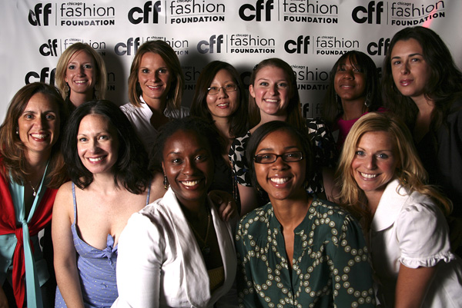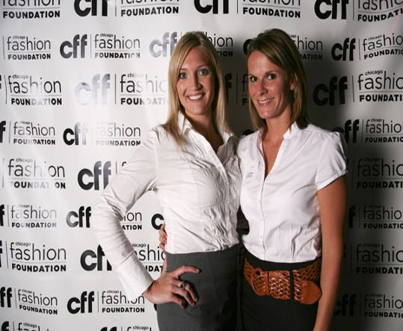
CFF’s Annual Membership
Networking Event

- By Lauren Hutchison

The Altitude room on the 33rd floor of the W Chicago- Lakeshore, provided the engaging backdrop for the Annual Chicago Fashion Foundation Membership Networking Event, where an array of members and non members gathered to share one commonality; a passion for fashion in Chicago. Hors d’ oeuvres and Bacardi cocktails enticed guests as they worked the room. Highlighting the evening, the CFF board announced the launch of their new website: Chicagofashionfoundation.org., and their up coming participation in Fashion Focus Chicago with a two part seminar; “Getting Connected and Growing Your Online Business”, that will feature a keynote address from Threadless.com. Deluxe goodie bags circulated, filled with luxuries such as Ethel’s Chocolates, Icing by Claire’s jewelry, Romane fragrances, Pretty Afrika jewelry, a CD with sounds from Marc Riva, and much more. Guests that received raffle numbers in their goodie bags had a chance to win a Elyse C Bec scarf, K. Amato jewelry, or a gift basket filled with signature products from Mario Tricoci. The Chicago Fashion Foundation, a non-profit organization, is eager to make an impact in contributing to the educational needs of fashion students. In 2009, CFF will be holding its Scholarship Award Benefit where an exceptional design student will be presented with a $5,000 scholarship, doubling the award given this past year. As the momentum gains, the foundation continues to strive to maintain and develop the fashion industry in Chicago.

Success Story: Nicolette Karney and Lindsey Madigan of the SHE boutique

By: Leah Christoforidis


It all started poolside in Arizona, where Nicolette Karney and Lindsey Madigan shared their aspirations to open a boutique. Within eight months the two developed a strong bond and working relationship. SHE boutique opened its doors at 1024 W. Armitage, May 31st 2007, with Nicolette as owner and Lindsey Madigan as buyer. They credit much of their success to finding each other and their ability to balance each others strengths and weaknesses.

At only 25 years old, Nicolette and Lindsey were among the youngest at the markets. Rather then get discouraged, the two found a way to use their age as an advantage. They had the energy and drive to stay dedicated to create every woman's "dream closet". In just one year the store carries over 50 designers. In fact, they recently expanded and opened a second location in Highland Park. Watching their boutique grow motivates these ladies and drives them to continue their success.

SHE boutique prides itself in customer service and the ability to offer every woman the perfect addition to her wardrobe. Nicolette and Lindsey view fashion as a form of self-expression. The staff is dedicated to helping every customer bring out their inner fashion. By varying taste and style the two have created a collection that offers anything and everything season after season. SHE stands for She Has Everything.

The clientele ranges in age, occupation, and style. The staff is always available and willing to assist and suggest. Each time the staff sees a new customer's eyes light up on the floor or witnesses the positive reaction in the dressing room, they are reassured that SHE boutique is a place for every woman.

The energy doesn't just stop in the store. SHE boutique is committed to raising fashion awareness throughout the city. Nicolette and Lindsay are looking forward to participating in future Chicago Fashion weeks. Set to hit the market soon, is the new SHE skin care line.

Be sure to stop by the store, but make sure you have some time. There are so many options to bring to the fitting room and it is impossible to leave without an armful of shopping bags. (Bring back their reusable bag, and receive 10% off your next purchase). And don't forget; ask for a sample of the soon to be released skin care.


In Fashion


I FOUGHT IT ON eBAY
Suing over eBay was big news on both sides of the Atlantic this summer. In the U.S., a Manhattan federal court handed down its long-awaited decision on Tiffany’s claims that eBay wasn’t doing enough to police and prevent online sales of counterfeits.1 Tiffany’s loss in New York stands in sharp contrast to very similar cases against eBay recently won by LVMH and Hermes in France.

What happened and what does it mean?

Tiffany v. eBay Lawsuit
The Claims
In its 2004 lawsuit, Tiffany made claims against eBay of trademark infringement, unfair competition, false advertising and trademark dilution, under one or both federal and New York State law, all arising out of the sale of counterfeit items by others through eBay. Huge volumes of purported Tiffany silver merchandise were offered on eBay, and eBay actively promoted the development of online jewelry auctions, including by use of the Tiffany name. It was not disputed that a great deal of the purported Tiffany items were counterfeits. Tiffany participated in eBay’s VERO (Verified Rights Owner) program, through which a “Notice of Claimed Infringement” (NOCI) can be filed, leading to the shutdown of the auction of the challenged item. Tiffany filed almost 285,000 NOCIs with eBay from mid-2003 through September 30, 2007.

eBay argued it had taken technologically reasonable measures to identify and remove counterfeits. Besides VERO, eBay performed various “fraud engine” searches on items being offered, flagged suspect items for review by eBay staff, and, in numerous cases, removed the items from the site. Over time, other changes were made by eBay, including prohibiting “Buy It Now” non-auction sales for purported Tiffany objects (meaning there was more time to detect and review them) and creating a multi-hour hold period before postings referring to Tiffany appeared (for similar
reasons).

1 Tiffany (NJ) Inc. v. eBay Inc., 04 CV 4607 (RJS)(S.D.N.Y.)(July 14, 2008).

The Result
The heart of the ruling is its analysis of the contributory infringement claim. The court treated eBay like the owner of a flea market who knows infringing goods might be sold at the market. But it was not proven that eBay knew or had reason to know of the infringement. So while the court accepted eBay had sufficient control over the transactions to have potential liability, and that eBay had a general awareness of the Tiffany counterfeiting problem, the claim failed because Tiffany had not shown that eBay failed to address specific instances of infringement that had been brought to its attention.

The court also rejected a “willful blindness” claim, finding that eBay generally
implemented additional anti-fraud measures when it was reasonably and technologically able to do so. Without specific knowledge, Tiffany was not obliged to do more. The court rejected the claim that eBay continued to “supply” its service to known infringers, because in most, if not all cases, where there

1 Tiffany (NJ) Inc. v. eBay Inc., 04 CV 4607 (RJS)(S.D.N.Y.)(July 14, 2008).

David Jacoby
212.745.0876
djacoby@schiffhardin.com
Judith S. Roth
212.745.0878
jroth@schiffhardin.com
Maxim H. Waldbaum
212.745.0815
mwaldbaum@schiffhardin.com
Stacie R. Hartman
312.258.5607
shartman@schiffhardin.com
Chris L. Bollinger
312.258.5724
cbollinger@schiffhardin.com
Lori D. Greendorfer
212.745.0814
lgreendorfer@schiffhardin.com
Amy M. Rubenstein
312.258.5625
arubenstein@schiffhardin.com
Preston C. Delashmit
404.437.7050
pdelashmit@schiffhardin.com
Robert E. Lesser
404.437.7051
rlesser@schiffhardin.com
Marc Silverman
212.745.0872
msilverman@schiffhardin.com
Harold S. Nathan
212.745.0813
hnathan@schiffhardin.com

The Result
The heart of the ruling is its analysis of the contributory infringement claim. The court treated eBay like the owner of a flea market who knows infringing goods might be sold at the market. But it was not proven that eBay knew or had reason to know of the infringement. So while the court accepted eBay had sufficient control over the transactions to have potential liability, and that eBay had a general awareness of the
Tiffany counterfeiting problem, the claim failed because Tiffany had not shown that eBay failed to address specific instances of infringement that had been brought to its attention.

The court also rejected a “willful blindness” claim, finding that eBay generally implemented additional anti-fraud measures when it was reasonably and technologically able to do so. Without specific knowledge, Tiffany was not obliged to do more. The court rejected the claim that eBay continued to “supply” its service to known infringers, because in most, if not all cases, where there had been multiple complaints, the poster had been removed. The court found it unreasonable to require removal on the basis merely of an interested party’s one-time “good faith” claim of infringement — some of which claims had turned out to be wrong.

The unfair competition claims failed because there was no evidence of bad faith by eBay. False advertising and dilution (blurring and tarnishment) claims also were rejected. A more novel claim of “contributory infringement” — that eBay invited people to do this — fared no better than the more familiar claims. Joint and several liability for Tiffany (along with the posters of counterfeit items) was rejected by the court because eBay never had possession of nor did it sell the purported Tiffany goods. Finally, the court held that eBay’s use of Tiffany’s trademarks — even in sponsored links on other sites — fell within
the “nominative” fair use doctrine; that is, that it used no more of the marks than needed to describe what was being sold and made no suggestion of any affiliation with Tiffany. Tiffany has filed a notice of appeal.

Meanwhile in France . . . .
A number of luxe product makers, including Dior and Louis Vuitton, prevailed on claims that eBay was selling counterfeit items and had a duty to stop doing so.2 LVMH prevailed on its claim although it had never participated in eBay’s VERO system. eBay pointed to the same sorts of safeguards that helped it persuade the U.S. court — VERO, fraud engines, 2006 upgrades to the technology — to no avail.

The Paris Commercial Tribunal found eBay was not a mere site host, which might enjoy statutory immunity, but a broker of the illicit items. While the American court said it was acceptable for eBay not automatically to eject counterfeit sellers after a first instance, the French court reached the opposite conclusion. It awarded the equivalent of over US$60 million in damages. An early June decision by another French trial court concerning eBay counterfeits had gone in favor of Hermes.

In a decision handed down at the same time, involving four fragrance makers under the LVMH wing3, the same court found eBay liable for taking no steps to prevent sales of items outside manufacturer-authorized distribution channels.

2 La Societe Christian Dior Couture, SA v. La Societe eBay Inc. (Tribunal de Commece de
Paris, jugement prononce 30 June 2008); SA Louis Vuitton Malletier v. eBay Inc. (Tribunal de
Commerce de Paris, judgment prononce 30 June 2008).
3 SA Parfums Christian Dior v. eBay Inc. (Tribuinal de Comemrce de Paris jugement pronounce
30 June 2008). In addition to Parfums Christian Dior, the other plaintiffs were Kenzo
Parfums, Parfums Givency and Guerlain.

2 La Societe Christian Dior Couture, SA v. La Societe eBay Inc. (Tribunal de Commece de
Paris, jugement prononce 30 June 2008); SA Louis Vuitton Malletier v. eBay Inc. (Tribunal de
Commerce de Paris, judgment prononce 30 June 2008).

In Fashion

Observations
1. While it acknowledges Tiffany’s frustration with the frequent appearance of phony Tiffany goods on
eBay, the U.S. court says policing is the rights owner’s burden. The court dwelled on the relative
efforts made and costs incurred by Tiffany and eBay in dealing with counterfeits. Consider this
contrast:

eBay spends $20 million yearly on tools to promote trust and safety on its web site; that’s what a quarter of its 16,000 employees do. Half work as customer service representatives. Some 200 do nothing but hunt for infringing items; another 70 work with law enforcement. eBay spent $5 million annually to upgrade its fraud search engine, updating it weekly from 2003 to 2006. The fraud engine flags thousands of suspect listings daily. Sometimes eBay reimbursed buyers of items that turned out to be counterfeit. eBay never refused to pull down an auction that was the subject of a Tiffany NOCI.

Tiffany spent $763,000 to deal with online counterfeiting in 2003, just 0.05% of its net sales. Over five years, it budgeted $14 million for anti-counterfeiting — three to five million dollars of which was for the Tiffany litigation against eBay. From 2003 to 2006, Tiffany spent the equivalent of just three person days a week (in-house) and between just 1.15 and 1.6 person days a week (outside
counsel) monitoring eBay. It only began to monitor eBay on a daily basis in 2006. Tiffany declined to use technological tools proposed by eBay to facilitate VERO reporting. Despite asking for the identities of the sellers of the assertedly phony items, Tiffany never sued one. Tiffany stopped pursuing sellers of counterfeit goods on eBay, either directly through cease and desist demands or
by assisting law enforcement authorities, in 2003.

The case thus reminds everyone of an old message: rights owners proceed at their peril
by not maintaining an economically reasonable level of trademark/trade dress enforcement activity. It’s a good moment for trademark owners to review their anticounterfeiting programs to make sure their scope and targets reflect a good faith effort to address the problem while also being cost-effective. Perhaps the U.S. court would have been more inclined to Tiffany’s view if it had gone after repeat quantity sellers of alleged counterfeits directly, as well as demanding that eBay do so. Distribution channel issues also should be considered to make sure what the rights owner does in one area is consistent with positions it takes in another.

2. Where there is licensing or franchising, who will be responsible for dealing with eBay sale of
counterfeits issues, and to what extent, should be addressed in the agreement.

3. Multi-national brands may find there is now more than one way to skin a counterfeiting
cat. Careful attention to where suit is brought could pay big returns. If a U.S. brand had a choice of
chasing eBay in the U.S. or in France, France might be a better choice right now, particularly if
distribution channel violations are involved.4 A French court’s judgment probably could be enforced
in any country in the European Union. Moreover, unlike situations in which pure speech and the First Amendment have been involved, U.S. courts may be more willing to enforce a French court’s
judgment in this context, where sales of goods are involved.

4 We are aware of at least one U.S. lawsuit, brought after the French decisions, which tries to
apply its breach of selective distribution channels argument to eBay — but it's still too early
for there to have been any decision.

“Green” Fashion: A Legal Perspective

Esther Barron, Director of Northwestern University School of Law’s Small Business Opportunity Center and Clinical Assistant Professor

Sheila Simhan, Clinical Fellow of Northwestern University School of Law’s Small Business Opportunity Center

One of the latest fashion trends is going “green.” As consumers’ appetite for environmentally friendly products increases, designers and retailers are scrambling to benefit from this movement and meet the demand. A growing number of designers are using biodegradable fabrics for their runways. Retail stores are stocking recycled thread and organic shirts and pants. But what are the current advertising and labeling requirements to be met by manufacturers and designers who undertake green fashion? It is usually prudent to consult an attorney on these legal standards, but you can often save time and money by having thought through these key regulations in advance.

Labeling “Green” Fashion

In the United States, every item of clothing labeled as “organic” or “100% organic” must meet the United States Department of Agriculture (USDA) National Organic Program standards. To label an item of clothing as “100 percent organic,” it must be made from 100 percent of organic fiber content made only from organic processing aids. To label an item of clothing as “organic,” it must be made from a minimum of 95 percent organic fiber content. The other 5 percent of the USDA Organic product can contain nonorganic substances, but only those on a USDA-approved list. With respect to both items of clothing labeled “organic” or “100% organic,” all operations that produce, handle, process and manufacture the final product must be certified by the USDA.

Internationally, a patchwork of organic labeling standards has lead to a great deal of confusion in the clothing industry. In an attempt to offer clarity on this issue, the International Association Natural Textile Industry has published the “Global Organic Textile Standard” (GOTS). GOTS unifies organic standards so manufacturers can market their products under one certification that is accepted by all major markets of the world. The Organic Trade Association of the United States (OTA), a membership-based business association for the organic business community in North America, has already signed the agreement and adopted GOTS. Whereas the USDA primarily regulates the labeling of organic fiber, GOTS covers the production, processing, manufacturing, packaging, labeling, exportation, importation and distribution of organic fibers.



Advertising “Green” Fashion
The federal trade commission (FTC) issued the Guides for the Use of Environmental Marketing Claims (“Green Guides”) to prevent the false or misleading use of environmental terms in product advertising. The Green Guides are not law but are administrative interpretations of FTC’s laws and are intended to help businesses advertise in compliance with the law. If conduct is inconsistent with the Green Guide, the result may be corrective action by the FTC. The Green Guides address four general concerns that apply to all environmental marketing claims:
First, disclosures or explanations pertaining to an environmental marketing claim must be clear and conspicuous in order to prevent deception. A hidden or small print disclosure would not be helpful to consumers.
Second, all marketing claims should specify whether it refers to the product, the packaging or just to a part of the product or its packaging. For example, a "recycled package" claim on the side of a shoe box could mean that both the cardboard box and paper wrapping inside the box are made from recycled content. The claim is deceptive if only the box is recycled. It should be qualified to say, for example, “recycled box.”
Third, environmental claims should not exaggerate or overstate environmental benefits. This point is illustrated in a recent revision of the Green Guides. It explains that a “chlorine free process” claim for a product is likely to overstate the environmental benefit of the manufacturing process if such process continues to release into the environment the same harmful byproduct associated with chlorine bleaching. Even though the claim is technically correct, it is likely to convey the false impression that any environmental risk posed by chlorine bleaching is absent from or significantly minimized by the manufacturing process.
Fourth, comparative environmental claims should be clear enough that consumers know what is being compared. For example, a t-shirt is advertised as “50% more organic cotton.” This claim is ambiguous because it could be a comparison to the marketer’s previous t-shirts or to a competitor’s t-shirts. The marketer should qualify the advertisement to say, for example, “50% more organic cotton than our previous t-shirts.”
While the Green Guides aim to protect consumers from false advertising, the Lanham Act (“the Act”), legislation enacted by the U.S. Congress, addresses harm to businesses based on alleged false or misleading statements. To prove false advertising under the Act, the claimant must prove that there was a false or misleading statement made, the statement was used in commercial advertising or promotion, and the statement creates a likelihood of harm to the plaintiff. For example, in a Lanham Act suit between two companies that each sell shaving products, the court ruled in favor of the plaintiff because it was found that the "six times smoother" advertising claim implied the consumer would receive an overall smoother shaving experience from the defendant's razor, a claim that was found to be false. To obtain money damages, as opposed to injunctive relief, a Lanham Act claimant must also demonstrate actual consumer reliance on the false advertising and resulting economic harm to its own business.

This article only touches upon some legal issues that businesses should consider when promoting and labeling clothing and other accessories as “green” fashion, and is not intended to be a comprehensive checklist. However, we hope it provides a general overview of regulations and standards and helps you consider the legal aspects of developing and manufacturing your line of “green” fashion.



Fall Trends
By: Katie Hickey

Living in Chicago from October through those long, harsh winters doesn’t mean we have to forfeit our style to Mother Nature. Monika Crossin, owner of Nika le butik in Park Ridge, has some great suggestions for staying on top of trends during this fall season.

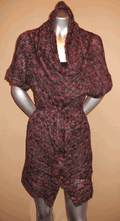
First, chunky knits have been seen all over the runways and can be worn many different ways. Layering over dresses or with tights and tall boots, this runway favorite will translate well into real life for a great fall trend. Having one or two oversized sweaters could be a great, timeless staple that can bring you right into winter.

Pictured: Kelly Nishimoto Cute as a Button Sweater Coat, $154


Bursts of color on silk to chiffon are a huge highlight this fall, especially on party and holiday dresses. Purples and deep reds can be your unexpected punch to fall, playing up any event on your schedule. Monika notes that these gorgeous jewel tones are being reflected in accessories as well.

Pictured: Ingwa Melero Lydia Silk and Velvet Halter Dress, $359

With the economy being so bad, a major change to your outfit can be done with something more affordable like a statement necklace. Monika suggests finding a statement necklace to turn your simple jeans and top outfit to completely change your look. Also, she has taken notice that designers are incorporating accessories into their clothing lines. This is a great way for the consumer to be a part of their favorite designer without having to splurge on an $800 dress.

Pictured: Necklaces



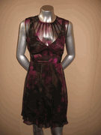
Three major trends making waves on runways this fall are floral prints, ruffles and fringe. Floral prints, Monika notes, were more last season, but fall florals look great on and off the runway. Currently, ruffles are a huge trend and look great with pencil skirts and menswear trousers. Ruffles are playing a big role at Nika and would be a great addition to your everyday wardrobe. They go well with anything and can instantly dress up a typical workday ensemble.

Pictured: Nu Collective Printed Empire Dress, $289; Jenny Han Ruffle Neck Silk Blouse, $184.

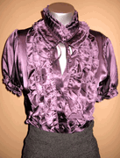
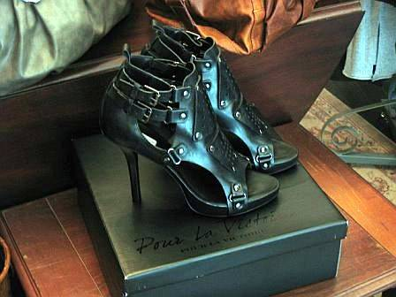

Shoes this season are following in the footsteps of the summer gladiator, but have a heel rather than the flat sandal. The Sacha Gladiator Heel by Pour La Victoire is a great example of what you should be looking for to play up a skinny jean or layered look. Shoes are being seen with hardware and even fringe and can make a big statement on their own. Riding boots and patent leather are also a noticeable trend.

Pictured: Pour La Victoire Sacha Leather Gladiator Heel, $285

All of these fall trends seem to display classic appeal and could make excellent additions to your fall and winter wardrobe. Splurging on a statement necklace or a luxurious knit could be just what you need to add some style excitement to the chilly months ahead.

Nika le butik is located at 143 N. Northwest Highway, Park Ridge, 60068. www.nikabutik.com

A Word from the CFF Board
CFF Bulletin

Editor Lauren Hutchison

Contributing
Writers Jennifer Burrell Lauren Hutchison
Leah Christoforidis
The Fashion group at
Schiff Hardin LLP
Esther Barron Sheila Simhan Katie Hickey

CFF Board
2008

President Kristen Amato

Vice President Sandra Enimil

Treasurer Elizabeth Engquist

Secretary Lauren Hutchison

Scholarship Sandra Enimil

Student
Membership Katie Vermylen

Retail
Membership Julie Gee

Public Relations Kristen Amato and
Sandra Enimil

Events Amanda Lea

Sponsorship Elysabeth Alfano

Communications Shatisha Wilks

Photography Katie Hanson

Founder
Lana Fertelmeister

Honorary Advisory Board Members

Rob Bramlette
Beth Lambert
Devin (McKenna) Javidi
Fabia Talhame

To Submit an article please email it to Staci@chicagofashionfoundation.com

www.chicagofashionfoundation.com

To contribute to CFF newsletter, please contact Lauren Hutchison: Lauren@
chicagofashionfoundation.org

We would like to thank our members, guests and sponsors for making the CFF Annual Membership Networking Event such a success. In addition, thank you to our fantastic speakers who contributed to the “Getting Connected and Growing Your Online Business Seminar” for Fashion Focus.

Congratulations to the semifinalists and finalists for the CFF Annual Scholarship! The 2009 CFF Scholarship Event is scheduled for March 4, 2009 from 6-8pm at Macy's on State St.

The five finalists that are in the running to win the $5,000 scholarship are:
Anna Gaukel -Columbia
Arushi Kumar- SAIC
Sandra X. Hanley- IADT
Randy Rusnadi - Harper College
Tara Reich- Columbia

